# CHAPTER 1

## INTRODUCTION

**Background of the Study**

Nowadays, due to the fast growth of technology, demands in move sophisticated innovations in different are increasing. Microprocessor is now used in creating such technology like artificial intelligence. From the compact ones to the sized and complex, application of artificial intelligence has already been visible especially to the gaming industry, The Game of Generals is one of the board games that need to be updated or upgraded to suffice the needs of enthusiast nowadays, Nanterme,2009.

The Game of the Generals, a board game also called GG as it is most fondly called, or simply The Generals, an educational war game invented in the Philippines, The GoG is not very popular or it is merely recognized. It is because foreign countries developed games that have great similarities with The Game of Generals, The GoG rose with the crowd in Makati on February 28, 1973. During this time the GoG attempted to outsell the Chess board game (Ronnie Pasola). The first tournament of The Game of Generals was also organized during the same time to promote it. After Manila The Game of Generals quickly spread through neighboring provinces and eventually spread throughout the country. The game of generals does not really bear a name of a person that introduced it with people. This game spread throughout the country including Mindanao. The game of generals is known to just spread through the people from representatives from Manila that are tasked to teach it to people. It can also be possible that is just spread through visitors or people teaching each other. Pasola, Jr,1970.

The proponent chose The Game of Generals Anime version Game to introduce the new level of Game of Generals with the Anime characters as the armies of the game.

**Statement of the Problem**

The following specific problems were found through research:

1. The Game of the Generals, can’t be played without an arbiter
2. Having difficulties for the kids to engage in the game because the armies at war lacks in characterization.
3. Lacks of portability, the player always need to carry the board including pieces to be able to play

**Objective of the Study**

To create a user friendly game called The GoG Game of Generals Anime Edition Versus mode game. The proponents developed objective that can be solve the problems that the proponents enlisted earlier. These are the following objective of the proponent:

1. To create a Game of Generals in a Versus Mode
2. To create a Anime characters as armies in Game of Generals for the kids to engage in the game
3. To create AI mode version of The Game of the Generals
4. To create a system that will follow the right decision of the game.

**Scope and Limitation**

These are the following scopes of the system

1. The system can be played with a versus mode with an AI as an opponent
2. Can identify the users Rank.
3. The system can announce the name of the person who lost in a challenge
4. The system can be played with the Anime characters as an armies in Game
5. The system has a tutorial game
6. The system has a point system for Win or Lose records

These are the following limitations of the system

1. The system is only aimed to upgrade or improve the board game system or manual system of The game of Generals Game
2. The system can only facilitate a maximum of two players.
3. The system cannot undo a players move.

**Significance of the Study**

This system entitled “The Game of the Generals Anime edition with AI and versus mode feature” provides convenience while playing the game. This also upgrades the playing of GoG to be in line with the modern and technological era.

**Community**

While playing the game, the audience will be able to watch the game and see the results. This game also indulges the technological upgrades that the The Game of Generals enthusiast need.

**User**

The Senior High School students of AMA Computer College can play comfortably and will engage the new kind edition of this game.

**Operational Definition of Terms**

Adobe Photoshop CS6 - An image editing software used to edit different I images for buttons, icons, wireframes, use-case diagram, context flow diagram, data flow diagram, and logo of (GGBOA) Game of Generals Battles of Anime.

Cascading Style Sheets (CSS) - CSS is a style sheet language used for describing the look and formatting of a document written in a markup language for for GG BOA (Game of the Generals: Battle of Anime’s).

HyperText Markup Language (HTML) - HTML is a standard markup language used to create web pages for GG BOA (Game of the Generals: Battle of Animes).

JavaScript - is a high level programming language used to create a program for GG BOA (Game of the Generals: Battle of Anime’s).

Microsoft Word 2010- is used to create a manuscript, table of contents, and front page for GG BOA (Game of the Generals: Battle of Anime’s).

Microsoft Power point - is used to create a visual presentation for GG BOA (Game of the Generals: Battle of Anime’s)

**CHAPTER 2**

**REVIEW OF RELATED LITERATURE AND SYSTEMS**

**Related Literature**

The Game of Generals, also called Salpakan and simply The Generals, is an educational war game invented in the Philippines by Sofronio H. Pasola Jr. in 1970. It can ba played within twenty to thirty minutes. It is designed for two players and requires to use of logic. The Game simulates armies at war trying to outflank and outmanoeuvre each other. As in actual warfare, the game allows only one side’s plan to succeed. Certain strategies and tactics, however, allow both sides the chances of securing a better idea of the other’s plan as the game progresses.

It was from the “The Game of Generals” at [www.boardgamegeek.com](http://www.boardgamegeek.com) that the proponents read that in 1980, Ideal released “The Generals Electronic Strategy Game. The rules and piece ranks are the same as above, except that the “Spies” are “Agents”, and an electronic arbiter determines which piece wins in a confrontation; neither player sees his opponent’s pieces. The Plastic pieces have selected notches on their bases, which depress certain identification in the electronic arbiter’s twin slots. The Light flash and a short musical phase play before a light labelled “Battle winner” is illuminated. The Losing piece is removed from the board, while the winning piece is placed back on the board. If the flag is placed in the arbiter, it plays “Taps” after the initial musical phase.

Unlike the original version of the game, if a player’s flag reaches the back row in The Generals Electronic Strategy Game, that player wins. Even if an opposing pieces occupies an adjacent square on the back row.

According to Pasella (1976), a similar game of strategy, Generals does not have any bombs, or miners to defuse them, are scouts to zip several spaces across the board in one move. New does Generals have any immovable pieces (both the flag and the bombs in strategy are stationary) In addition, unlike Strategy, which features two “lakes” in the middle of the board, all the squares on the board are accessible. Also each player has two Agents in Generals, while each only has one Spy in Strategy.

Anime is Japanese hand-drawn or computer animation. The word is the abbreviated pronunciation of "animation" in Japanese, where this term references all animation. Outside Japan, anime is used to refer specifically to animation from Japan or as a Japanese-disseminated animation style often characterized by colourful graphics, vibrant characters and fantastical themes. Arguably, the stylization approach to the meaning may open up the possibility of anime produced in countries other than Japan For simplicity; many Westerners strictly view anime as an animation product from Japan. Some scholars suggest defining anime as specifically or quintessentially Japanese may be related to a new form of orientalism. The earliest commercial Japanese animation dates to 1917, and production of anime works in Japan has since continued to increase steadily. The characteristic anime art style emerged in the 1960s with the works of Osamu Tezuka and spread internationally in the late twentieth century, developing a large domestic and international audience. Anime is distributed theatrically, by television broadcasts, directly to home media, and over the Internet. It is classified into numerous genres targeting diverse broad and niche audiences.

Anime is a diverse art form with distinctive production methods and techniques that have been adapted over time in response to emergent technologies. It consists of an ideal story-telling mechanism, combining graphic art, characterization, cinematography, and other forms of imaginative and individualistic techniques. The production of anime focuses less on the animation of movement and more on the realism of settings as well as the use of camera effects, including panning, zooming, and angle shots. Being hand-drawn, anime is separated from reality by a crucial gap of fiction that provides an ideal path for escapism that audiences can immerse themselves into with relative ease. Diverse art styles are used and character proportions and features can be quite varied, including characteristically large emotive or realistically sized eyes.

The anime industry consists of over 430 production studios, including major names like Studio Ghibli, Gainax, and Toei Animation. Despite comprising only a fraction of Japan's domestic film market, anime makes up a majority of Japanese DVD sales. It has also seen international success after the rise of The history of anime began at the start of the 20th century. The first generation of animators in the late 1910s included Ōten Shimokawa, Jun'ichi Kōuchi and Seitaro Kitayama, referred to as the "fathers" of anime.[1] During World War II, propaganda films such as Momotarō no Umiwashi (1943) and Momotarō: Umi no Shinpei (1945) were made,

the latter being the first anime feature film. During the 1970s, anime developed further, separating itself from its Western roots, and developing distinct genres such as mecha and its Super Robot subgenre. Typical shows from this period include "Astro Boy" Lupin III and Mazinger Z. During this period several filmmakers became famous, especially Hayao Miyazaki and Mamoru Oshii. In the 1980s, anime was accepted in the mainstream in Japan, and experienced a boom in production.

The rise of Gundam, Macross, Dragon Ball, and the Real Robot, space opera and cyberpunk genres set a boom as well. Space Battleship Yamato and The Super Dimension Fortress Macross also achieved worldwide success after being adapted respectively as Star Blazers and Robotech. The internet also led to the rise of fansub anime. The otaku culture became more pronounced with Mamoru Oshii's adaptation of Rumiko Takahashi's popular manga Urusei Yatsura (1981). Yatsura made Takahashi a household name and Oshii would break away from fan culture and take a more auteuristic approach with his 1984 film Urusei Yatsura 2: Beautiful Dreamer. This break with the otaku culture would allow Oshii to experiment further.

The otaku subculture had some effect on people who were entering the industry around this time. The most famous of these people were the amateur production group Daicon Films which would become Gainax. Gainax began by making films for the Daicon science fiction conventions and were so popular in the otaku community that they were given a chance to helm the biggest budgeted (to that point) anime film, Royal Space Force: The Wings of Honneamise (1987).

The success of Dragon Ball (1986) introduced the martial arts genre and became incredibly influential in the Japanese Animation industry. It influenced many more martial arts anime and manga series' including YuYu Hakusho (1990), One Piece (1999), and Naruto (2002). The 1980s brought anime to the home video market in the form of Original Video Animation (OVA). The first OVA was Mamoru Oshii's Moon Base Dallos (1983–1984). Dallos was a flop, but later titles like Fire Tripper, Leda:

The Fantastic Adventure of Yohko, and Megazone 23 (all 1985) were successful. Leda was in fact so successful, it was released theatrically at the end of the year. Shows such as Patlabor had their beginnings in this market and it proved to be a way to test less marketable animation against audiences.

The OVA allowed for the release of pornographic anime such as Cream Lemon (1984). The first hentai OVA was actually the little-known Wonder Kids Lolita Anime, also released in 1984. The 1980s also saw the amalgamation of anime with video games.

The airing of Red Photon Zillion (1987) and subsequent release of its companion game, is considered to have been a marketing ploy by Sega to promote sales of their newly released Master System in Japan. Sports anime as now known made its debut in 1983 with an anime adaptation Yoichi Takahashi's soccer manga Captain Tsubasa, which became the first worldwide successful sports anime leading its way to create themes and stories that would create the formula that would later be used in many sports series that soon followed such as Slam Dunk, Prince of Tennis and Eyeshield 21.

The late 1980s, following the release of Nausicaä, saw an increasing number of high budget and/or experimental films. In 1985 Toshio Suzuki helped put together funding for Oshii's experimental film Angel's Egg (1985). The OVA market allowed for short experimental pieces such as Take the X Train, Neo Tokyo, and Robot Carnival (all three 1987). Theatrical releases became more ambitious, each film trying to outclass or outspend the other film, all taking cues from Nausicaä's popular and critical success. Night on the Galactic Railroad (1985), Tale of Genji (1986), and Grave of the Fireflies (1988) were all ambitious films based on important literary works in Japan. Films such as Char's Counterattack (1988) and Arion (1986) were lavishly budgeted spectacles.

This period of lavish budgeting and experimentation would reach its zenith with two of the most expensive anime film productions ever: Royal Space Force:

The Wings of Honneamise (1987) and Akira (1988). Most of these films did not make back the costs to produce them. Neither Akira nor Royal Space Force: The Wings of Honneamise were box office successes in Japan. As a result, large numbers of anime studios closed down, and many experimental productions began to be favored less over "tried and true" formulas. Only Studio Ghibli was able to survive a winner of the many ambitious productions of the late 1980s with its film Kiki's Delivery Service (1989) being the top grossing film for 1989 earning over $40 million at the box office. Despite the failure of Akira in Japan, it brought with it a much larger international fan base for anime. When shown overseas, the film became a cult hit and, eventually, a symbol of the medium for the West.

The domestic failure and international success of Akira, combined with the bursting of the bubble economy and Osamu Tezuka's death in 1989, brought a close to the 1980s era of anime.

. This rise in international popularly has resulted in non-Japanese productions using the anime art style, but these works are usually described as anime-influenced animation rather than anime proper.

Artificial Intelligence (AI) is the ability of a computer program or a machine to think and learn. It is also a field of study which tries to make computers "smart". John McCarthy came up with the name "artificial intelligence" in 1955. The goal of AI research is to create computer programs that can learn, solve problems, and think logically. AI involves many different fields like computer science, mathematics, linguistics, psychology, neuroscience, and philosophy. Eventually researchers hope to create a "general artificial intelligence" which can solve many problems instead of focusing on just one. Researchers are also trying to create creative and emotional AI which can possibly empathize or create art. Many approaches and tools have been tried.ac

AI research really started with a conference at Dartmouth College in 1956. It was a month long brainstorming session attended by many people that are important in AI today. At the conference they wrote programs that were amazing at the time, beating people at checkers or solving word problems.

The U.S. Department of Defense started giving a lot of money to AI research and labs were created all over the world. Unfortunately, researchers really underestimated just how hard some problems were. The tools they had used still did not give computers things like emotions or common sense.. AI research revived in the 1980s because of the popularity of expert systems, which simulated the knowledge of a human expert. By 1985, 1 billion dollars were spent on AI. New, faster computers convinced U.S and British governments to start funding AI research again. However, the market for Lisp machines collapsed in 1987 and funding was pulled again, starting an even longer AI winter. AI revived again in the 90s and early 2000s with its use in data mining and medical diagnosis.

This was possible because of faster computers and focusing on solving more specific problems. In 1997, Deep Blue became the first computer program to beat chess world champion Garry Kasparov. Faster computers and access to more data have made AI popular throughout the world.

**Related Systems**

These were the related systems for the research:

**1. Electronic Salpakan game with touch screen feature**

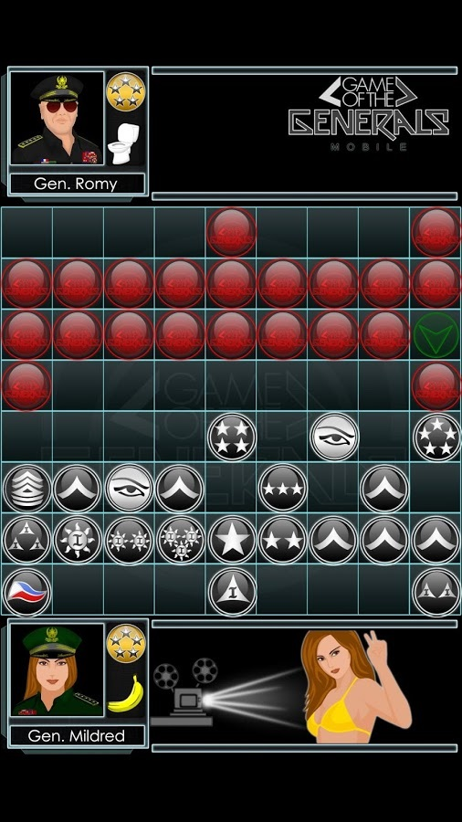

Figure 2.1.1 Electronic Salpakan game with touch screen feature

Electronic Salpakan game with touch screen feature was a comprehensive, electronic game. The proponents relate their study to the presented microprocessor project “Electronic Salpakan Game with touch screen feature” wherein they used a Artificial intelligence. Proponent’s microprocessor project is similar to the process of playing the game the manual way. But the gameplay of “The Game of the Generals anime version” is much modernized and it is easier to play.

**2.** **3D Mathematical Board Game Slide For Math**

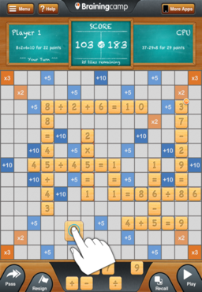

Figure 2.1.2 3D Mathematical Board Game Slide For Math

Mathematical Board Game Slide For Math was a comprehensive 3D game this also relate their study the presented Bachelor of science in Computer Science thesis project “Number Scrabble” by Jenneth Luardo and Michelle Maagma (2001) AMACC Quezon City . Wherein they used the concept of the real scrabble board is similar to the process of playing the game Game of Generals. But the gameplay of “it is modernized and it is easier to play with the AI concept for the software building of the game.

1. **SalpakanNa v3.40**

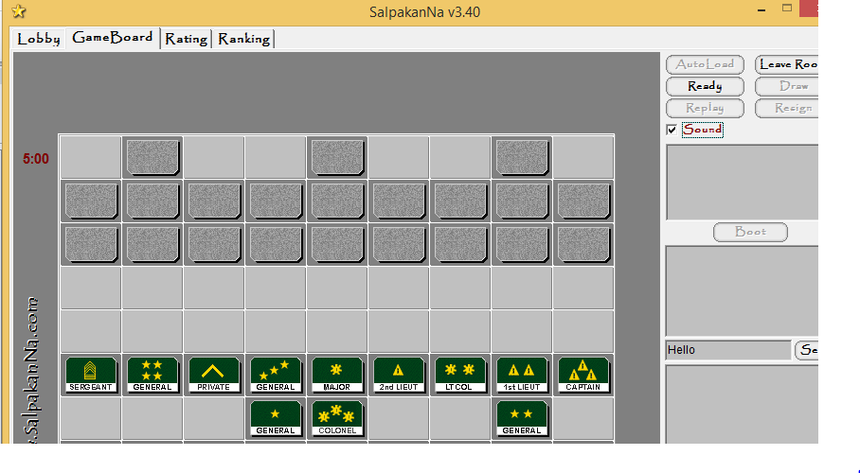

Figure 2.1.3 SalpakanNa v3.40

SalpakanNa v3.40 is a simple web application game, the user interface of this application was sharp and crisp. It has also the same features like creating a Multiplayer game and AI mode, this application has a variety of features like joining a game in lobby and has a Players ranking but the user Interface is not modernize but it has a concept of Artificial Intelligence for building the web application game

**CHAPTER 3**

**MATERIALS AND METHODOLOGY**

This chapter is intended to explain the research contents design and project implementation that shows how the research has been managed and organized.

**Research Design**

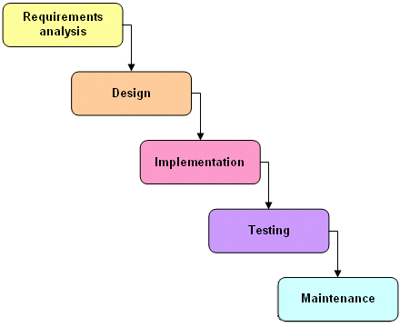

Figure 3.1.1 System Development Life Cycle (Waterfall Model)

The researchers used the descriptive research methodology which information was collected through interviewing. The researcher conduct a survey to gather information about their knowledge about the system. In the last part of the document, the researchers’ observations were described and explained.

In addition, the researchers used the waterfall model for software development. The said methodology for software development was used to guide the researchers on how to develop the design and programming of the system.

**Project Environment**

**Research Locale**

This study was conducted at the AMA Computer College Davao Campus located at 123 General Malvar Street, Davao City, Philippines.

**Population of the study**

The respondents of this study are the Saint Agustine International School Students or even any students who are interested to play this game, GGBOA (Game of the Generals: Battle of Animes).

**Timetable**

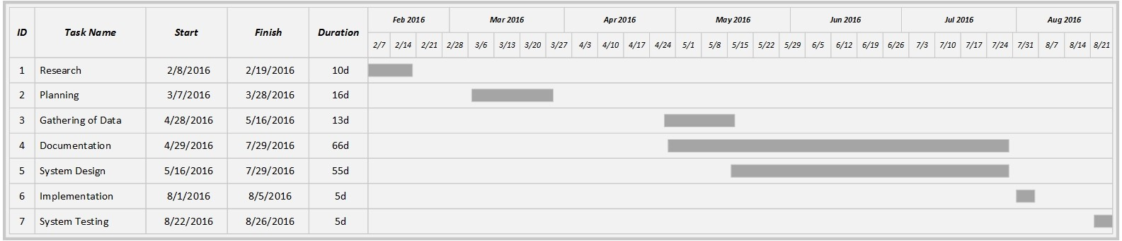

The table shown above described the progress of our research and implementation.

**Research** – this is about looking for subject to conduct our proposed study in our capstone project.

**Planning** – the researchers planned the steps to do and what to focus on in order to fulfil our study.

**Gathering of Data** – researchers gathered data through interviews, observation, analysis and questionnaire.

**Documentation** – researchers recorded the information gathered and its relevance to the study.

**System Design** – researchers designed what the system looks like through prototyping

**Implementation** – researchers created the system for our study and implement those software features in resolving the problems.

**System Testing** – after the implementation and the said system was completed the researchers tested the system to ensure its functionality.

**Data Gathering Instruments**

Instruments or tools that we used for data gathering in our study.

**Interview**

A conversation in which the interviewer asked questions to the interviewee face to face to gather data to solve those said problems.

**Observation**

Researchers used all of senses to examine people in natural settings or naturally occurring situations.

**Analysis**

Define the research problem; develop and implement a sampling plan; conceptualized, operationalize and develop a design structure for the project

**Questionnaire**

Researchers made an investigation to the St Agustine International School Students by giving them questionnaire to answer to gather accurate information.

**Figure 3: Timetable**



Figure 3 shows the researchers Gantt chart for the schedule of every task. It shows that the project planning started on February and the development ended on August.

**Data Gathering Instruments**

The researchers used questionnaires, empirical observation and interview with the students of SAIS and gathered information that the researchers found useful for the study.

**Data Gathering Procedures**

1. The researchers conducted an interview

The St Agustine International School were the respondents of the interview to figure out what their interest in our system.

2. Ask permission to conduct the study.

The researchers asked permission to the Principal of Saint Agustine International School before conducting the study.

3. The researchers conducted a research from the dental clinic.

The researchers collected information that supported the study. Asked information about what instruments they used to gather data from their patients.

4. Analysed and interpreted the data that has been collected.

All information collected were analysed to provide a more accurate and proper output of the interview.

**Methodology**

The researchers used the Prototyping Methodology. Users were actively involved in the development since in this methodology a working model of the system was provided. It helped a better understanding of the system developed for the users.

**Requirements Specification**

In this section, the Use-Case Diagram and Use-Case Specification related to function of the said system to be developed was included.

**Use Case Diagram**

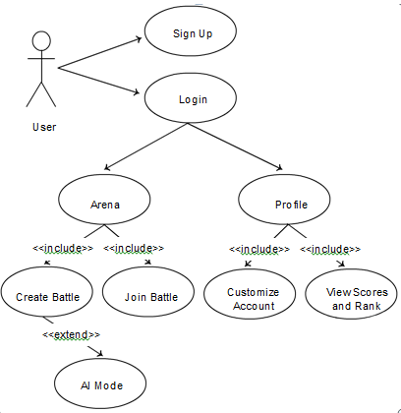

**Figure 4: Use Case Diagram of GG BOA**

Figure 4 shows what every user can do to the system and what the system offers to its user. The user needs to register. After the registration the user can log in. The user has its privilege to create and join a battle. The user can manage his or her profiles such as customize account and view scores and rank. User can play the game with an AI.

**Use Case Specification**

Table 1

**UC-1: User’s Registration**

|  |  |
| --- | --- |
| ID | UC-1 |
| Title | User’s Registration |
| Description | The user will register to the website. Upon registration, he/ she must input information. |
| Primary Actor | User |
| Preconditions | 1. There must be no existing username for registration confirmation. |
| Basic Flow of Events | 1. User should click “Sign Up” button for registration, 2. System will display the registration form. 3. The user should fill in the registration form. 4. All required fields must be filled up so that registration will be successful. |
| Alternative Flows | 3.a The system will display a message if the username is existing.  4.b The system will display an error message “Please Fill up all required fields” |
| Includes /Extension Points | 1. User’s information |
| Post-conditions | 1. The user is successfully registered in the website. |
| Status | ON-GOING DEVELOPMENT |
| Priority | HIGH |

Table 1 shows user’s registration where user needs to fill up and register to the website.

Table 2

**UC-2: User’s Login**

|  |  |
| --- | --- |
| ID | UC-2 |
| Title | User’s Login |
| Description | The user will log- in by inputting an existing account. |
| Primary Actor | User |
| Preconditions | 1. The user must be a registered in the database. |
| Basic Flow of Events | 1. The Login form is the default form in the index. 2. The user should fill in the log- in form and input an existing account. 3. User should click “Login” button for log- in. 4. All required fields must be filled up so that login will be successful. |
| Alternative Flows | 4.a The system will display a message if the username is existing.  5.a The system will display an error message “Please Fill up all required fields” |
| Includes /Extension Points | 1.User’s Credential |
| Post-conditions | 1. The user is successfully logged-in in the website. |
| Status | ON-GOING DEVELOPMENT |
| Priority | HIGH |

Table 2 shows user’s log in where user will log in to the system.

Table 3

**UC-3: User’s Arena: Create Battle**

|  |  |
| --- | --- |
| ID | UC-3 |
| Title | User creates battle. |
| Description | The user will create a battle. |
| Primary Actor | User |
| Preconditions | 1. The user must be a registered in the database. |
| Basic Flow of Events | 1. User should click “Create Battle” button to create a battle. 2. System will display the create battle form. 3. The user should fill in the create battle form. 4. The user should click the “Start” button. 5. All required fields must be filled up so that the created period will be successful. |
| Alternative Flows | 5.a The system will display an error message “Wait for the other players” |
| Includes /Extension Points | 1. Period Information |
| Post-conditions | 1. The user has successfully created a battle. |
| Status | ON-GOING DEVELOPMENT |
| Priority | MEDIUM |

Table 3 shows how the user creates a battle.

Table 4

**UC-4: User’s Arena: Create Battle Vs. AI Mode**

|  |  |
| --- | --- |
| ID | UC-4 |
| Title | User creates battle versus AI Mode. |
| Description | The user will create a battle versus AI Mode. |
| Primary Actor | User |
| Preconditions | 1. The user must be a registered in the database. |
| Basic Flow of Events | 1. User should click “Create Battle” button to create a battle. 2. System will display the create battle form. 3. The user should fill in the create battle form. 4. The user should click the “AI Mode” button. 5. The user should click the “Start” button. 6. All required fields must be filled up so that the created period will be successful. |
| Alternative Flows | 5.a The system will display an error message “Please click AI Mode.” |
| Includes /Extension Points | 1. Period Information |
| Post-conditions | 1. The user has successfully created a battle for AI Mode. |
| Status | ON-GOING DEVELOPMENT |
| Priority | MEDIUM |

Table 4 shows how the user creates a battle versus AI Mode.

Table 5

**UC-5: User’s Arena: Join Battle**

|  |  |
| --- | --- |
| ID | UC-5 |
| Title | User joins a battle. |
| Description | The user will join a battle. |
| Primary Actor | User |
| Preconditions | 1. The User must be a registered in the database. |
| Basic Flow of Events | 1. User should Click “Join Battle” button to join the battle. 2. System will display Join Battle form. 3. The user should select the battle. 4. There must be a battle selected so that the user who joins the battle will be successful. |
| Alternative Flows | 5.a The system will display an error message “Please Select a Battle” |
| Includes /Extension Points | 1. Period Information |
| Post-conditions | 1. The user has successfully joined the battle. |
| Status | ON-GOING DEVELOPMENT |
| Priority | MEDIUM |

Table 5 shows how the user will join a battle.

Table 6

**UC-5: User’s Profile**

|  |  |
| --- | --- |
| ID | UC-6 |
| Title | User views his or her profile. |
| Description | The user will manage his or her profile. |
| Primary Actor | User |
| Preconditions | 1. User must be a registered user. |
| Basic Flow of Events | 1. User should click “Profile” to customize and view scores and rank. 2. System will display the user’s profile form. 3. The user can customize and view his or her scores and rank. 4. User must be already played the game so that he or she can view his or her scores and rank. |
| Alternative Flows | 5.a The system will display an error message “You don’t have scores and rank yet.” |
| Includes /Extension Points | 1. Period Information |
| Post-conditions | 1. The user has successfully managed his or her profile. |
| Status | ON-GOING DEVELOPMENT |
| Priority | MEDIUM |

Table 6 shows how the user manages his or her profile.

**Design**

**Project Design**

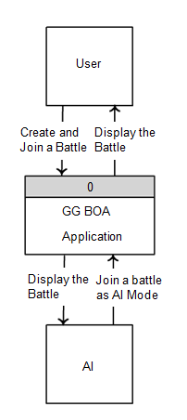

Figure 3.4.1 Context Diagram

Figure 3.4.1 shows the context diagram of the system where the user can create and join a battle to the web application, but the AI can only join the battle when it is in AI mode. Then it displays the battle.

**Data Flow Diagram**

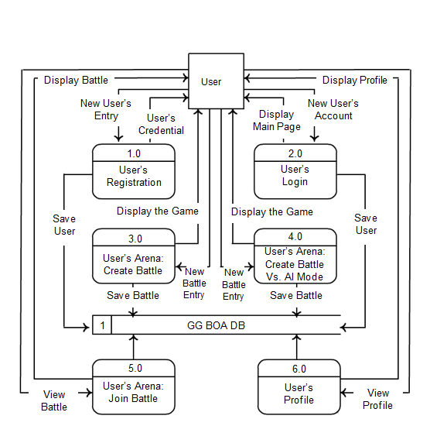

Figure 3.3.Data Flow Diagram

Figure 7 shows the process of data in the system, the process starts with registration. After the user create an account. The user has its privilege to create a battle. The user can also create battle Vs. AI Mode. The user has its privilege to view his or her profile and also can customize account and view scores and rank.

**Output and User-Interface Design**

**Screen Layout/Wire Frames**

Figures in the section are the wireframes of the system.

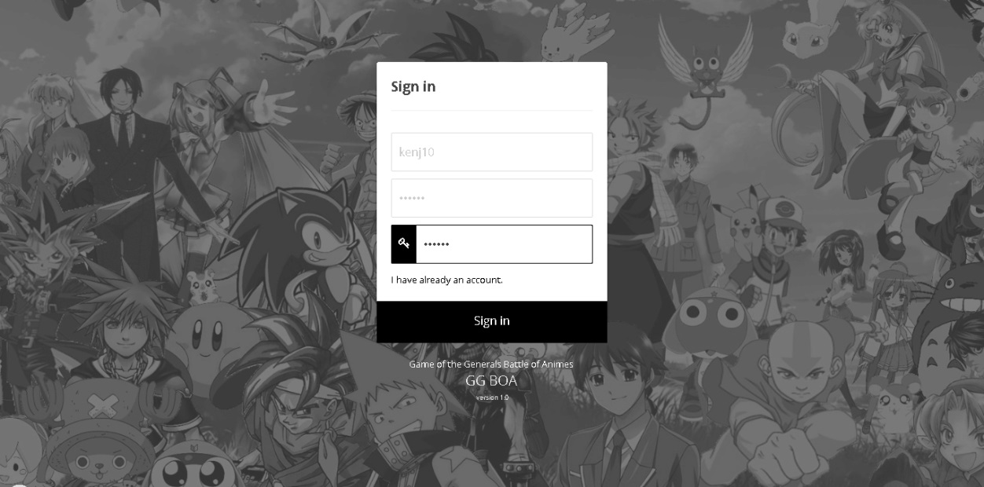

**Figure 7: User’s Registration**

Figure 7 shows how the wireframe for user’s registration where the user will register.

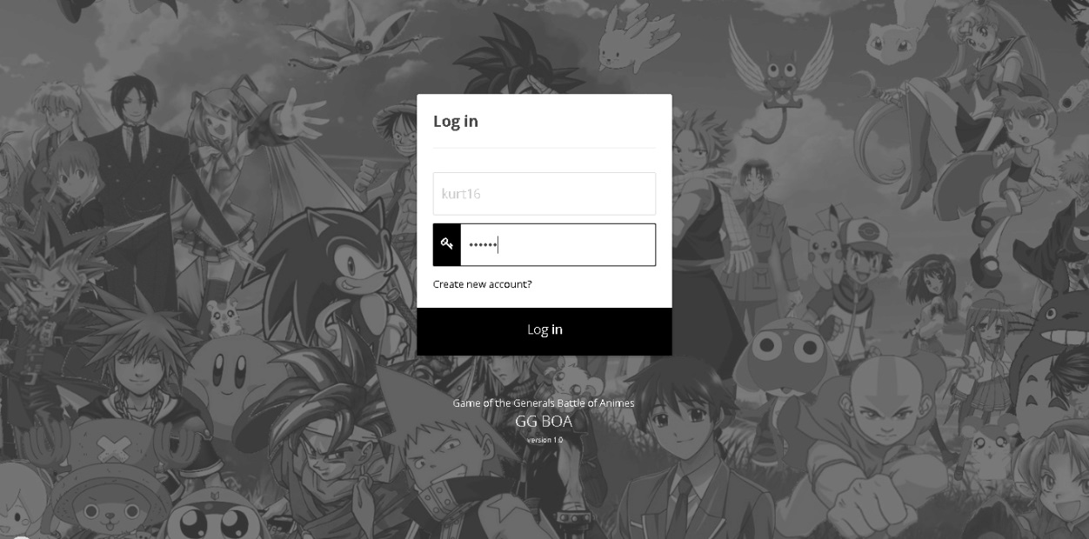

**Figure 8:** **User’s Login**

Figure 8 shows how the wireframe for user’s Login where the user will login.

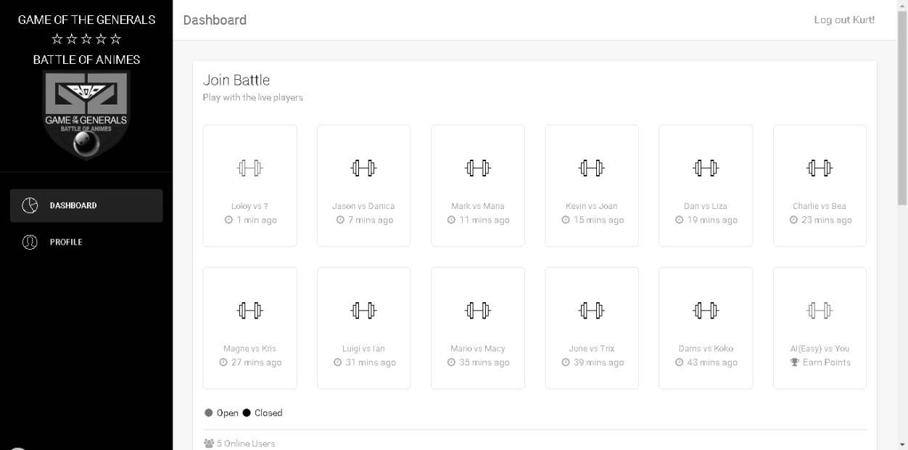

**Figure 9:** **Main Page**

Figure 9 shows how the wireframe for the main page of the system where the user will create, join, and manage user’s profile.

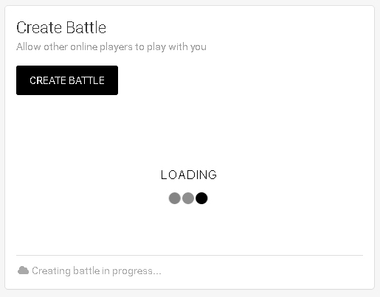

**Figure 10:** **Create Battle**

Figure 10 shows how the wireframe for create battle where the user will create battle for other user and for VS. AI Mode.

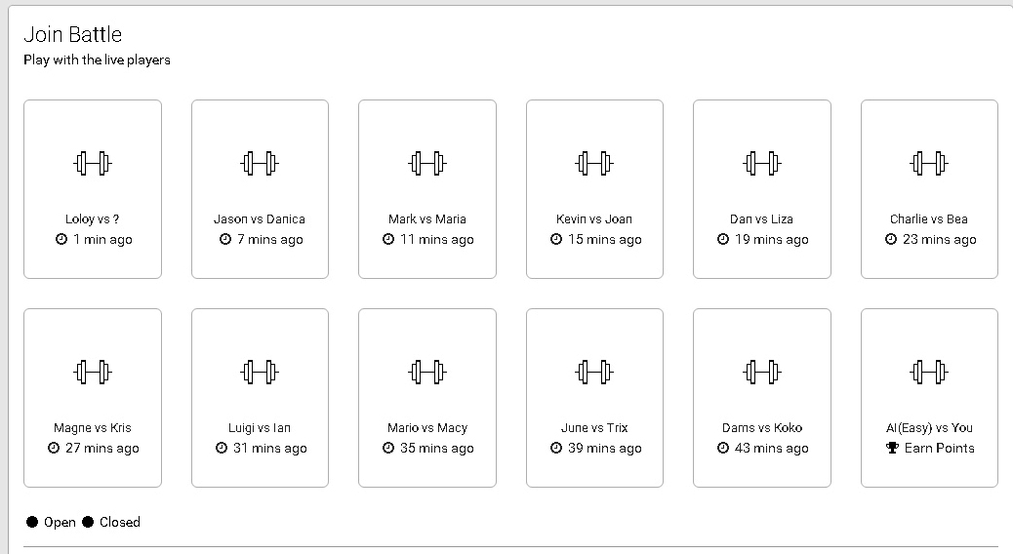

**Figure 11:** **Join Battle**

Figure 11 shows how the wireframe for join battle where the user will join a battle.

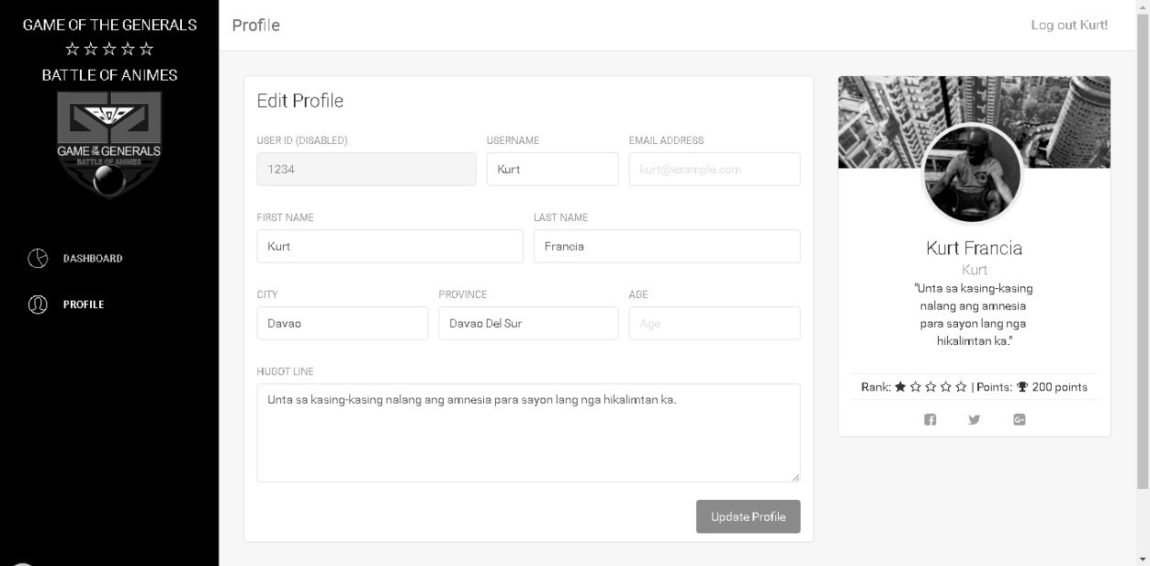

**Figure 12:** **User’s Profile**

Figure 12 shows how the wireframe for user’s profile where the user will manage his or her profile.

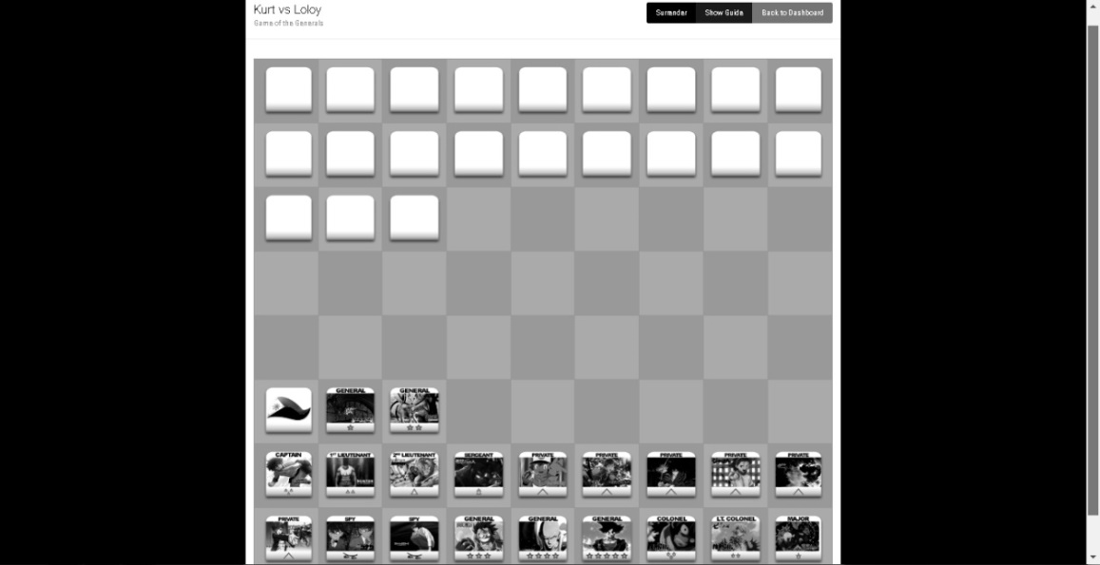

**Figure 13:** **Battle Field**

Figure 13 shows how the wireframe for battle field where the users will play the game.

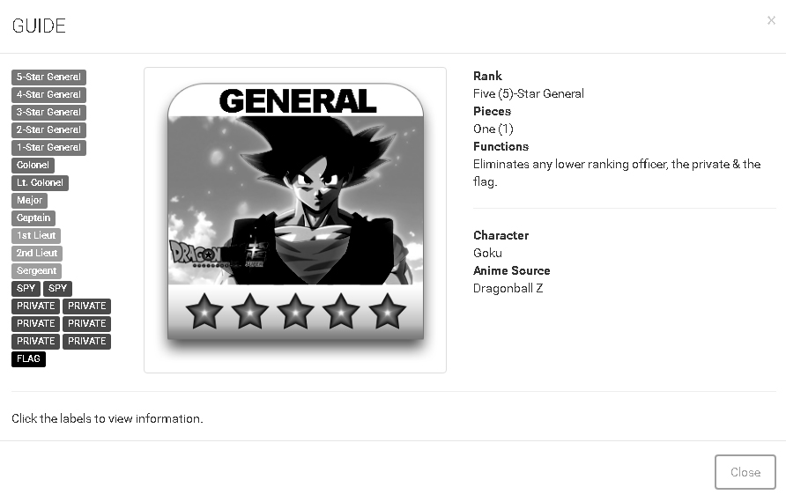

**Figure 14:** **Guide**

Figure 14 shows how the wireframe for guide where the users will view the guide and description of characters of the game.

**Data Design**

This includes the design that shows the data dictionary tables of the system.

**Data Dictionary**

|  |  |  |  |  |  |  |  |  |  |
| --- | --- | --- | --- | --- | --- | --- | --- | --- | --- |
| Table 3.0 Table ggboa_user | | | | | | | | | |
|  | | | | | | | | | |
| **PF** | | **Field Name** | | **Caption** | **Data type** | **Field** | | **Notes** | |
| PK | | id | |  |  |  | |  | |
| Pk | | username | | Register id | Variable Character | 15 | |  | |
| FK | | password | | Password | Variable Character | 15 | |  | |
|  | | profileid | | Profile id | Variable Character | 30 | |  | |
|  | | status | | Status | Variable Character | 10 | |  | |
| Table 3.1 ggboa_battle | | | | | | | | | | |
|  | | | | | | | | | | |
| **PF** | | **Field Name** | | **Caption** | | **Data type** | | **Field** | | **Notes** |
| P | | battleid | | Battle id | | Integer | | 10 | |  |
|  | | creator | | creator | | Variable Character | | 30 | |  |
|  | | opponent | | Opponents name | | Variable Character | | 10 | |  |
|  | | created | | Created | | Variable Character | | 30 | |  |
|  | | points | | Battle points | | Variable Character | | 50 | |  |
|  | | state | | status | | Variable Character | | 6 | |  |
|  | | status | | status | | Datetime | |  | |  |

|  |  |  |  |  |  |  |  |  |  |  |  |  |
| --- | --- | --- | --- | --- | --- | --- | --- | --- | --- | --- | --- | --- |
| Table 3.2 ggboa_challenges | | | | | | | | | | | | |
|  | | | | | | | | | | | | |
| **PF** | | **Field Name** | | **Caption** | | **Data type** | | **Field** | | **Notes** | |
| P | | name | | username | | Int | | 10 | |  | |
| F | | player | | password | | Int | | 11 | |  | |
|  | | computer | | Computer | | Varchar | | 30 | |  | |
|  | |  | |  | |  | |  | |  | |
| Table 3.3 ggboa_profile | | | | | | | | | | | |
|  | | | | | | | | | | | |
| **PF** | | **Field Name** | | **Caption** | | **Data type** | | **Field** | | **Notes** | |
| P | | username | | Books id | | Variable Character | | 15 | |  | |
|  | | email | | Email address | | Variable Character | | 20 | |  | |
|  | | firstname | | First Name | | Variable Character | | 50 | |  | |
|  | | lastname | | Last name | | Variable Character | | 50 | |  | |
|  | | city | | City | | Variable Character | | 10 | |  | |
|  | | province | | Publisher | | Variable Character | | 50 | |  | |
|  | | age | | Edition | | Variable Character | | 50 | |  | |
|  | | about | | Number of copies | | Variable Character | | 50 | |  | |
|  | | image | | Status | | Variable Character | | 50 | |  | |
|  | | points | | Copyright | | int | | 10 | |  | |

|  |  |  |  |  |  |
| --- | --- | --- | --- | --- | --- |
| Table 3.4 ggboa_battlelog | | | | | |
|  | | | | | |
| **PF** | **Field Name** | **Caption** | **Data type** | **Field** | **Notes** |
| PK | battleid | Battle ID | Integer | 10 |  |
| F | playerid | Player Id | Integer | 10 |  |
| F | playernum | Player number | Integer | 10 |  |
|  | places | places | Variable Character | 20 |  |
|  | remarks | remarks | Integer |  |  |
|  | timestamp | Timestamps | Integer |  |  |

|  |  |  |  |  |  |
| --- | --- | --- | --- | --- | --- |
| Table 3.4 ggboa_battlesetup | | | | | |
|  | | | | | |
| **PF** | **Field Name** | **Caption** | **Data type** | **Field** | **Notes** |
| P | battleid | Battle ID | Integer | 10 |  |
|  | Creator_pieces | Creator Pieces | Variable Character |  |  |
|  | Opponent_pices | Opponent pieces | Variable Character |  |  |
|  | Creator_isready | Creator ready | Variable Character |  |  |
|  | Opponent_isready | Opponents ready | Variable Character | 11 |  |
| Table 3.5 ggboa_profilebattlesetup | | | | | |
|  | | | | | |
| **PF** | **Field Name** | **Caption** | **Data type** | **Field** | **Notes** |
| P | Setup_it | Set up | Integer | 10 |  |
|  | playernum | Player Number | Integer |  |  |
|  | Profile_id | Profile ID | Integer |  |  |
|  | Battle_setup | Battle Setup | Variable Character |  |  |
|  | status | Online or Offline | Variable Character | 11 |  |

|  |  |  |  |  |  |
| --- | --- | --- | --- | --- | --- |
| Table 3.6 ggboa_profilebattlesetup | | | | | |
|  | | | | | |
| **PF** | **Field Name** | **Caption** | **Data type** | **Field** | **Notes** |
| P | profileid | Profile ID | Integer | 10 |  |
|  | challengeid | Challenge ID | Integer |  |  |

**Design**

The following diagrams and prototype describe the logical and structural design of the proposed system.

**Entity Relationship Diagram**

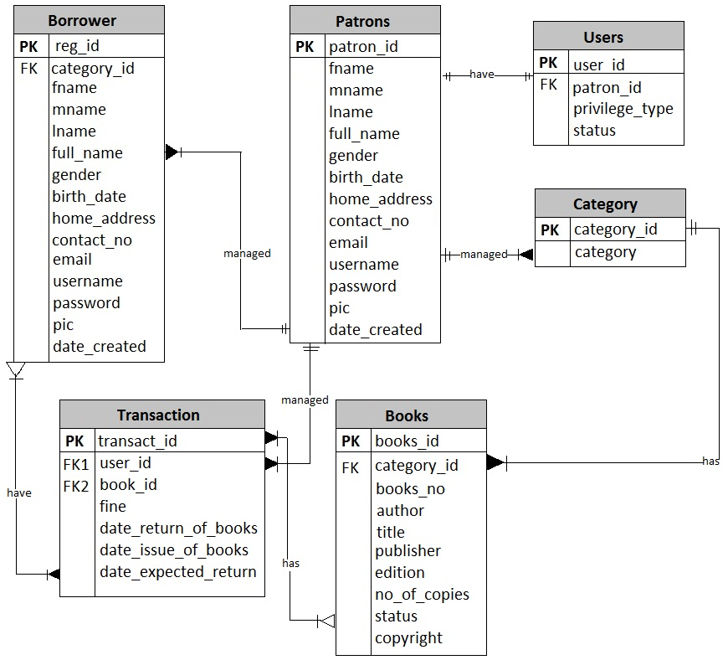

Figure 6 Entity Relationship Diagram (ERD).

Figure 6 shows the entity relationship diagram of the system.

**Development**

This includes the software specification, hardware specification, program specification, deployment diagram, and test plan of the system.

**Software Specification**

Table 4.0 Software Specification of GGBOA (Game of Generals Anime version game

|  |  |
| --- | --- |
| **Software Specification** | |
| **Operating System** | Windows 7, 32 bit |
| **Database** | MySQL and MySQLi |
| **Server** | FTP Server and 0fees.com |
| **Software** | Apache, PHP MyAdmin, Sublime text 2 and Bootstrap |
| **Programming language** | PHP, HTML5, CSS3, Javascript, AJAX, Unity |

Table 4.0 shows the software specification of the system.

**Hardware Specification**

Table 4.1 Hardware Specification of online GGBOA (Game of Generals Battles of Animes)

|  |  |  |
| --- | --- | --- |
| **Web** | | |
| **Factors** | **Minimum** | **Recommended** |
| **Processor** | Intel Atom | Intel core 2 or higher |
| **Memory** | 1.0 RAM | 2.0 RAM or higher |
| **Operating system** | Windows 2000/XP | Windows 7 or higher |
| **Screen Resolution** | 800 X 600 | 1366 x 768 or higher |
| **Web browser** | Internet explorer (any version), Google Chrome, Safari, Mozilla Firefox, Opera | |

Table 4.1 shows the hardware specification for online GGBOA (Game of Generals Battles of Animes)

Table 4.2 Program specification

|  |  |
| --- | --- |
| **Program Specification** | |
| **Programming Languages** | PHP, HTML5, CSS3, JAVASCRIPT, AJAX, Unity |
| **3rd Party Software** | Apache, Xampp, PHPMyAdmin, Sublime text 2, Bootstrap. Jpgraph, Oracle |
| **Database** | MySQL, MySQLi |

Table 4.2 shows the programming languages, software and databases that used by the researchers to meet the system’s requirements.

**Deployment Diagram**

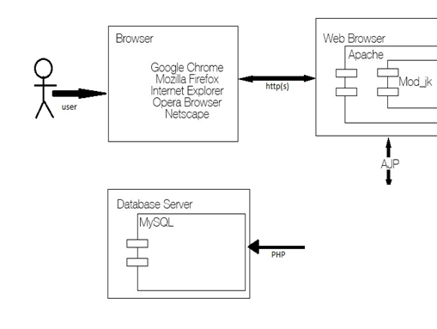

Figure 7 Deployment Diagram

Figure 6 shows the deployment structure of online GGBOA (Game of Generals Battles Of Animes)

Arcia Kurt M. Francia

Title: GGBOA Game of Generals Battles of Animes

**Test Plan**

**Table 3.5.1 Test Case 1 (Register an Account)**

|  |  |
| --- | --- |
| **Test Case:** | TC - 1.0 |
| **System:** | GGBOA Game of Generals Battles of Anime |
| **Designed by:** | Researchers |
| **Executed by:** | Users |
| **Description:** | Test the register feature of the system |
| **Test Case Name:** | Register |
| **Design Date:** | February 2017 |
| **Execution Date:** | February 2017 |

|  |
| --- |
| **Pre-condition** |
| The user must have a registered account |

Table 7

**TC1: User’s Registration**

|  |  |
| --- | --- |
| Test Case #: 1 | Test Case Name: User’s Registration |
| System: Game of the Generals: Battle of Animes | |
| Short Description: The user will fill up the form. | |
| Pre-Conditions   1. The user must be connected to the internet. | |
| |  |  |  |  | | --- | --- | --- | --- | | Procedural Steps | Expected Result | Pass | Fail | | 1. User will click “Sign Up” button from the index for registration. | System will display the registration form. |  |  | | 1. The user will fill up form and enter his or her first name, last name, username, and password. | System will check if the username is valid and check if the required fields are filled. |  |  | | 1. The user will click “Register” button. | All required fields must be filled up so that registration will be successful. |  |  | | |
| Post-Conditions  The user is successfully registered. | |

**Table 3.5.2 Test Case 2 (Login)**

|  |  |
| --- | --- |
| **Test Case:** | TC - 1.1 |
| **System:** | GGBOA Game of Generals Battles of Anime |
| **Designed by:** | Researchers |
| **Executed by:** | Users |
| **Description:** | Test the Login |
| **Test Case Name:** | Logins |
| **Design Date:** | February 2017 |
| **Execution Date:** | February 2017 |

|  |
| --- |
| **Pre-condition** |
| The user must be logged-in to the application |

**Table 8**

**TC2: User’s Login**

|  |  |
| --- | --- |
| Test Case #: 2 | Test Case Name: User’s Login |
| System: Game of the Generals: Battle of Animes | |
| Short Description: The user will input an existing account. | |
| Pre-Conditions   1. The user must be a registered in the database. | |
| |  |  |  |  | | --- | --- | --- | --- | | Procedural Steps | Expected Result | Pass | Fail | | 1. Login form is default in the index page. | System will display the Login form in the index. |  |  | | 1. The user will input an existing account. | System will check if the username is registered and check if the password is correct. |  |  | | 1. The user will click “Login” button. | All required fields must be filled up so that login will be successful. |  |  | | |
| Post-Conditions  The user is successfully login. | |

**Table 3.5.2 Test Case 3 (Create Battle)**

|  |  |
| --- | --- |
| **Test Case:** | TC - 1.3 |
| **System:** | GGBOA Game of Generals Battles of Anime |
| **Designed by:** | Researchers |
| **Executed by:** | Users |
| **Description:** | Create Battle |
| **Test Case Name:** | Create Battle |
| **Design Date:** | February 2017 |

Table 9

**TC3: User’s Arena: Create Battle**

|  |  |
| --- | --- |
| Test Case #: 3 | Test Case Name: User’s Arena: Create Battle |
| System: Game of the Generals: Battle of Animes | |
| Short Description: The user will create a battle. | |
| Pre-Conditions   1. The teacher must be a registered in the database. | |
| |  |  |  |  | | --- | --- | --- | --- | | Procedural Steps | Expected Result | Pass | Fail | | 1. User will click “Create Battle” button to create a battle. | System will display the create battle form. |  |  | | 1. The user will fill up in the create battle form. | System will save the form. |  |  | | 1. The user will click “Start” button to play the game. | Player must wait other player who will join the battle so battle will be successful. |  |  | | |
| Post-Conditions  The user has successfully created a battle. | |

**Table 3.5.2 Test Case 4 (Create Battle vs AI Mode)**

|  |  |
| --- | --- |
| **Test Case:** | TC - 1.4 |
| **System:** | GGBOA Game of Generals Battles of Anime |
| **Designed by:** | Researchers |
| **Executed by:** | Users |
| **Description:** | Create Battle vs AI Mode |
| **Test Case Name:** | Create Battle vs AI Mode |
| **Design Date:** | February 2017 |

**Table 10**

**TC4: User’s Arena: Create Battle Vs. AI Mode**

|  |  |
| --- | --- |
| Test Case #: 4 | Test Case Name: User’s Arena: Create Battle  Vs. AI Mode |
| System: Game of the Generals: Battle of Animes | |
| Short Description: The user will create a battle Vs. AI Mode. | |
| Pre-Conditions   1. The user must be registered in the database. | |
| |  |  |  |  | | --- | --- | --- | --- | | Procedural Steps | Expected Result | Pass | Fail | | 1. User will click “Create Battle” button from the dashboard. | System will display the “Create Battle” form. |  |  | | 1. The user will fill up the create battle vs. AI mode form. | System will save the form |  |  | | 1. The user will click “Start” button to play the game. | Player no needs to wait other player so that battle will be successful. |  |  | | |
| Post-Conditions  The user has successfully created a battle vs. AI mode. | |

**Table 3.5.2 Test Case 4 (Join Battle)**

|  |  |
| --- | --- |
| **Test Case:** | TC - 1.5 |
| **System:** | GGBOA Game of Generals Battles of Anime |
| **Designed by:** | Researchers |
| **Executed by:** | Users |
| **Description:** | Join Battle |
| **Test Case Name:** | Join Battle |
| **Design Date:** | February 2017 |

**Table 11**

**TC5: User’s Arena: Join Battle**

|  |  |
| --- | --- |
| Test Case #: 5 | Test Case Name: Create Trimester Period |
| System: Game of the Generals: Battle of Animes | |
| Short Description: The user will join a battle. | |
| Pre-Conditions   1. The user must be a registered in the database. | |
| |  |  |  |  | | --- | --- | --- | --- | | Procedural Steps | Expected Result | Pass | Fail | | 1. User will click “Join Battle” form. | System will display the join battle form. |  |  | | 1. The user will select a battle. | System will display the selected battle. |  |  | | 1. The user will click “Ready” button. | Battle must be selected so that join battle will be successful. |  |  | | |
| Post-Conditions  The user has successfully joined a battle. | |

**Table 3.5.2 Test Case 5 (Users Profile)**

|  |  |
| --- | --- |
| **Test Case:** | TC - 1.6 |
| **System:** | GGBOA Game of Generals Battles of Anime |
| **Designed by:** | Researchers |
| **Executed by:** | Users |
| **Description:** | Customizing Users Profile |
| **Test Case Name:** | Users Profile |
| **Design Date:** | February 2017 |

**Table 12**

**TC6: User’s Profile**

|  |  |
| --- | --- |
| Test Case #: 6 | Test Case Name: User’s Profile |
| System: Game of the Generals: Battle of Animes | |
| Short Description: The user will manage his or her profile. | |
| Pre-Conditions   1. The user must be a registered in the database. | |
| |  |  |  |  | | --- | --- | --- | --- | | Procedural Steps | Expected Result | Pass | Fail | | 1. User will click “Profile” button to customize his or her profile. | System will display the user’s profile. |  |  | | 1. The user will customize and view his or her scores and rank. | System will save the customized profile. |  |  | | 1. The user will click “customize” button. | User must fill up all fields so that customize profile will be successful. |  |  | | |
| Post-Conditions  The user has successfully customized his or her profile. | |

**Criteria**

* Passed – the system met all the expected results distinguished in the description provided by the user.
* Failed – the system did not meet the expected results distinguished in the description provided by the user.

**Verification, Validation and Testing**

The proponents verified the development and ensured that the system met the objective and specification and delivers functionalities expected by the panelist. The proponents examined the input and outputs of the system’s operational behaviour to check if it is performing as required. The proponents validated the system that was approved by the panellists to fit to its intended purpose. After all the approved verification and validation testing, the proponents tested the system’s overall functionalities and defined the system behaviour if it is working completely, is stable and is well maintained.

**Unit testing**

The unit testing was a part of system development process which involves individual testing unit of code separately to ensure the system worked by its own. It is independent to other units. The proponents set essential path to perform and examine different path through modules.

**Integration** **testing**

Integration testing takes place on the basis of functionalities of the system, as documented in the functional specification set by the panelist. Integration testing tests integration of interfaces between components, interaction of the system different parts of the system such as the operating system, file system and hardware or interface between systems.

**System Testing**

The proponents’ task is to ensure that the behavior of the whole system is well tested and defined the scope development. This included testing based on the requirements, specification, test cases, behavior of the system, and interaction with the operating system and system resources. System testing is often the most final step that researchers do. It ensures that the system was verified well and delivers and meets the objectives of the study and its purpose. The proponents tested and investigated both functional and non-functional requirements of the testing.

**CHAPTER 4**

**RESULTS AND DISCUSSION**

This chapter presents the results and discussion from the methods used by the researchers in the previous chapter.

**Project Description**

GGBOA (Game of Generals battles of Anime) is a game website that aims to encourage the players by playing the game with Anime characters as the armies in the game. The Game of Generals Battles of Anime can be played with a versus mode and an AI as an opponent, The system can identify the Players rank by the points given every after the game and it can easily be played because the system has a tutorial during the match. The system has a players information and also allowing them update their records and information. Additional features of the system that allows them to manage their user profiles.

**Project Structure**

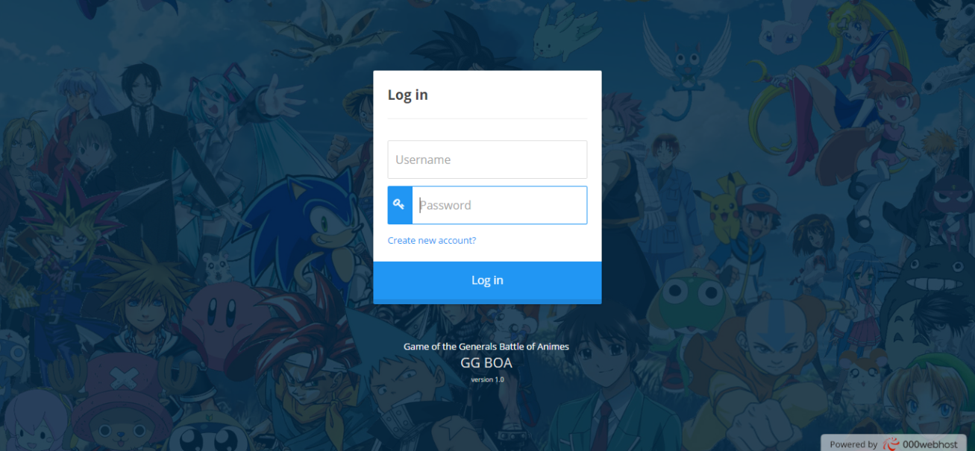

Figure 4.1.1 Login Form

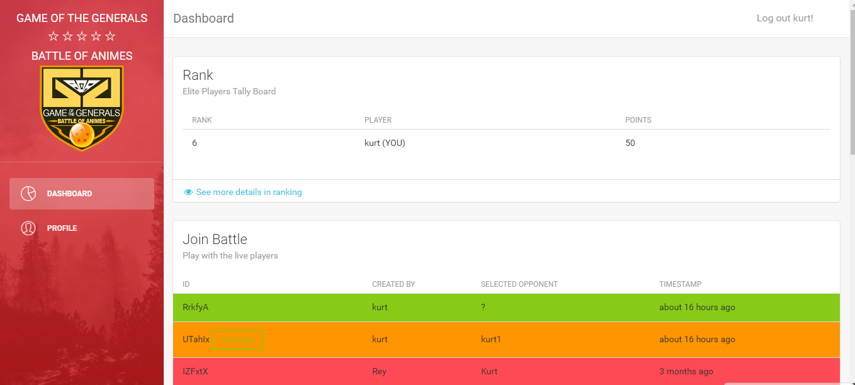

Figure 4.1.2 Dashboard

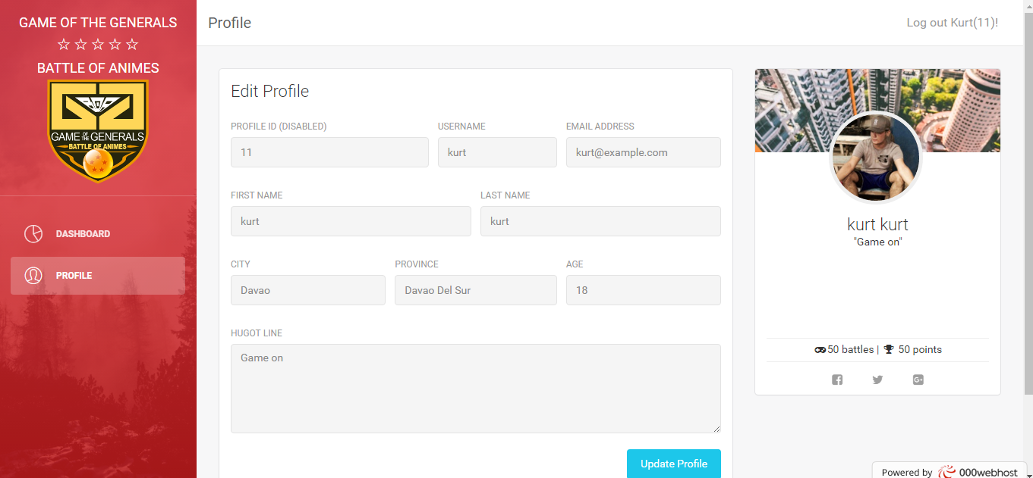

Figure 4.1.3 Players profile

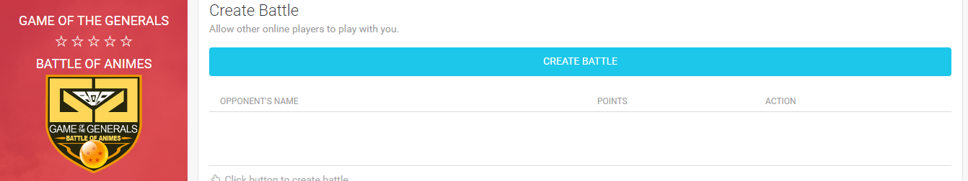

Figure 4.1.4 Create Battle

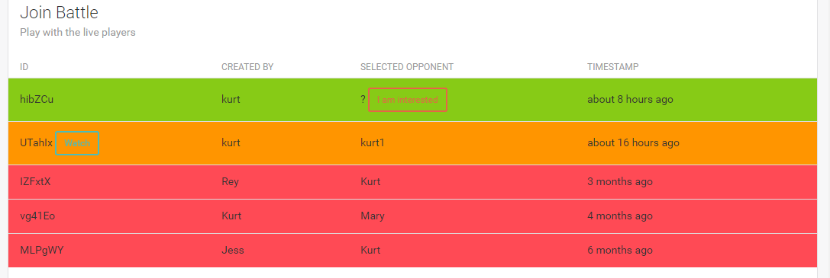

Figure 4.1.5 Selecting battles to join.

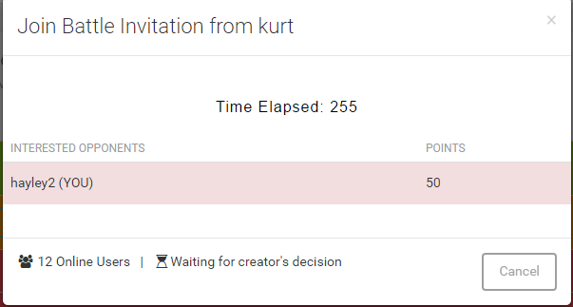

Figure 4.1.6 Join Battle Invitation

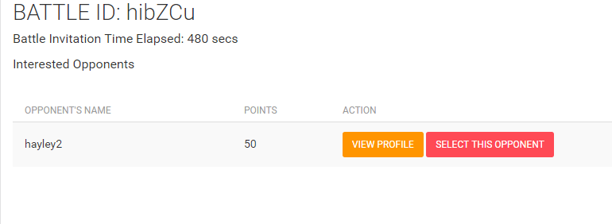

Figure 4.1.7 Selecting of Opponents

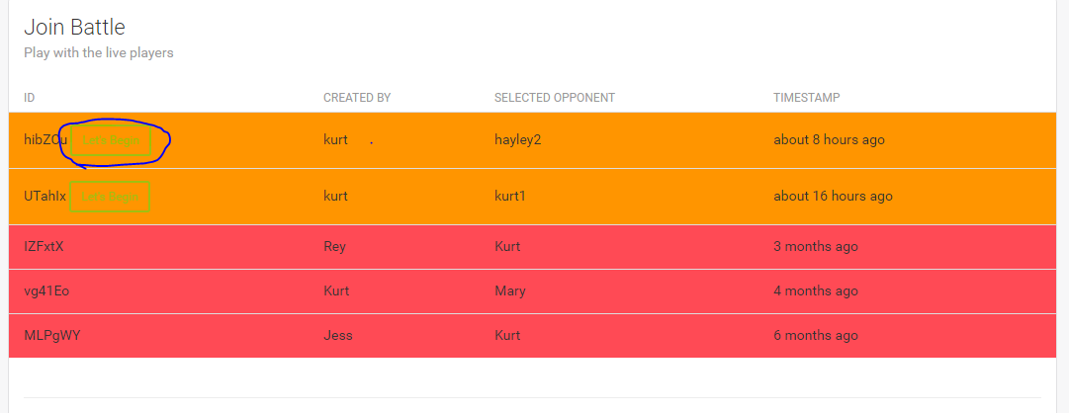

Figure 4.1.8 Beginning battle.

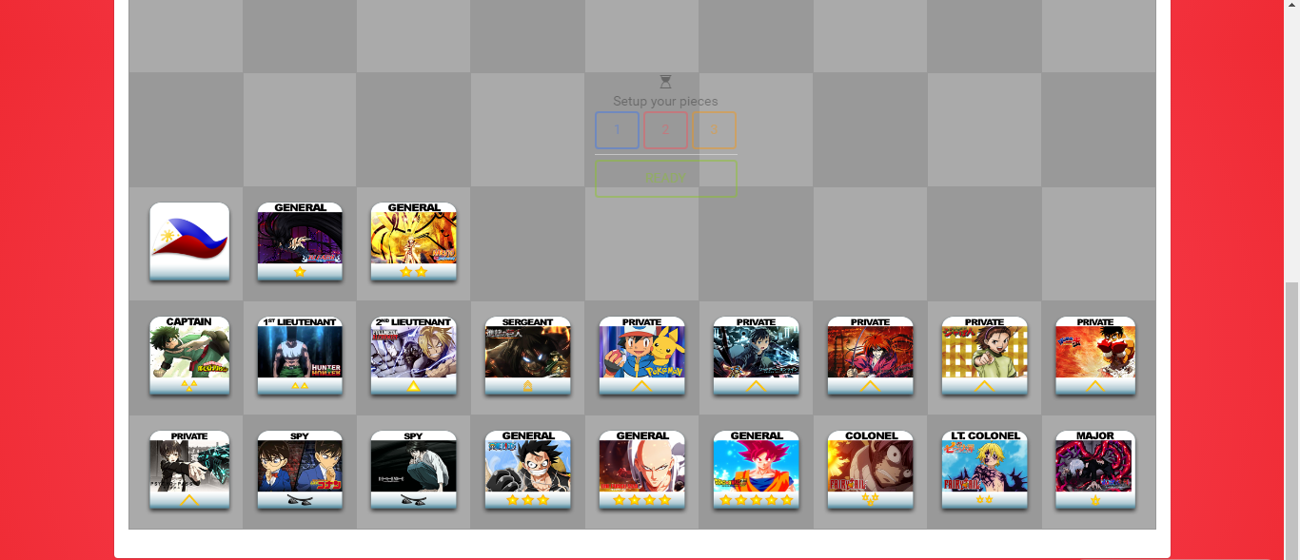

Figure 4.1.9 Battle Field

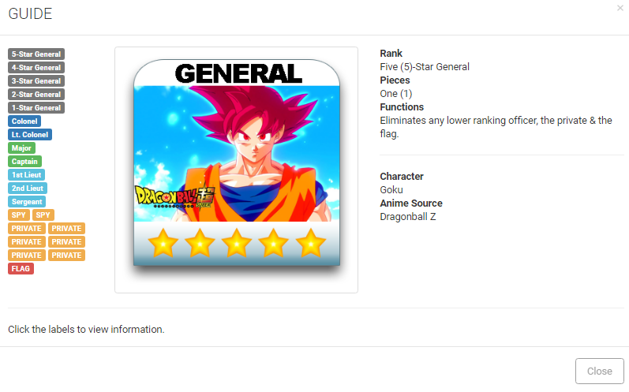

Figure 4.1.10 Players Guide

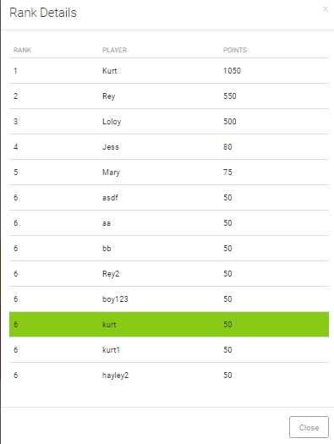

Figure 4.1.11 Players Rankings and Points

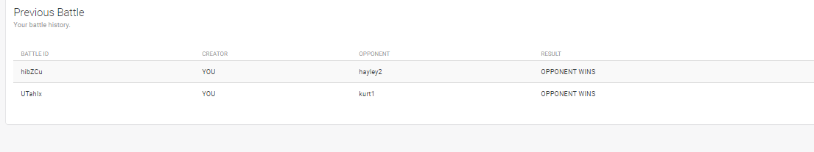

Figure 4.1.12 Player Battles History



Figure 4.1.12 Users Battle points

**Project Capabilities and Limitation**

**Capabilities**

1. The system stores the gathered data to a database for organization.

2. The system sends an SMS to notify the patient for an appointment.

3. The system can generate and print a report.

4. The system has a system notification.

5. Admin can create a user account.

6. The system can schedule a database backup.

**Limitation**

1. Visual treatment plan in not in 3D mode.
2. Visual treatment plan in not customizable.
3. User must ask for a registration of an account to be able to login in the system.
4. Does not allow payments for treatment.

**Test Plan**

**Test Case**

Table 4.1.1 Result Test Case 1 (Login)

|  |  |  |  |  |
| --- | --- | --- | --- | --- |
| **Step** | **Action** | **Expected system response** | **Pass/Fail** | **Comment** |
| 1 | Enter a username | The system will check if the username entered is existed in the database. | Pass |  |
| 2 | Enter password | The system will check if the password is exist in the database and matches together with the username. | Pass |  |
| 3 | Click “login” button | The system will show the main form of the system. | Pass |  |

Table 4.1.2 Result Test Case 2 (Registration)

|  |  |  |  |  |
| --- | --- | --- | --- | --- |
| **Step** | **Action** | **Expected system response** | **Pass/Fail** | **Comment** |
| 1 | User will click sign up button from the index for registration | The system will check if the username entered is existed in the database. | Pass |  |
| 2 | Enter password | The system will check if the password is exist in the database and matches together with the username. | Pass |  |
| 3 | Click “login” button | The system will show the main form of the system. | Pass |  |

Table 4.1.3 Result Test Case 1 (Create Battle)

|  |  |
| --- | --- |
| Test Case #: 3 | Test Case Name: User’s Arena: Create Battle |
| System: Game of the Generals: Battle of Animes | |
| Short Description: The user will create a battle. | |
| Pre-Conditions   1. The teacher must be a registered in the database. | |
| |  |  |  |  | | --- | --- | --- | --- | | Procedural Steps | Expected Result | Pass | Fail | | 1. User will click “Create Battle” button to create a battle. | System will display the create battle form. | Pass |  | | 1. The user will fill up in the create battle form. | System will save the form. | Pass |  | | 1. The user will click “Start” button to play the game. | Player must wait other player who will join the battle so battle will be successful. | Pass |  | | |
| Post-Conditions  The user has successfully created a battle. | |

Table 4.1.4 Result Test Case 1 (Create Battle vs. AI mode)

|  |  |
| --- | --- |
| Test Case #: 4 | Test Case Name: User’s Arena: Create Battle  Vs. AI Mode |
| System: Game of the Generals: Battle of Animes | |
| Short Description: The user will create a battle Vs. AI Mode. | |
| Pre-Conditions  The user must be registered in the database. | |
| |  |  |  |  | | --- | --- | --- | --- | | Procedural Steps | Expected Result | Pass | Fail | | 1. User will click “Create Battle” button from the dashboard. | System will display the “Create Battle” form. | Pass |  | | 1. The user will fill up the create battle vs. AI mode form. | System will save the form | Pass |  | | 1. The user will click “Start” button to play the game. | Player no needs to wait other player so that battle will be successful. | Pass |  | | |
| Post-Conditions  The user has successfully created a battle vs. AI mode. | |

Table 4.1.5 Result Test Case 1 Users Profile

|  |  |
| --- | --- |
| Test Case #: 6 | Test Case Name: User’s Profile |
| System: Game of the Generals: Battle of Animes | |
| Short Description: The user will manage his or her profile. | |
| Pre-Conditions   1. The user must be a registered in the database. | |
| |  |  |  |  | | --- | --- | --- | --- | | Procedural Steps | Expected Result | Pass | Fail | | 1. User will click “Profile” button to customize his or her profile. | System will display the user’s profile. | Pass |  | | 1. The user will customize and view his or her scores and rank. | System will save the customized profile. | Pass |  | | 1. The user will click “customize” button. | User must fill up all fields so that customize profile will be successful. | Pass |  | | |

Table 4.1.5 Result Test Case 1 (Join Battle)

|  |  |
| --- | --- |
| Test Case #: 5 | Test Case Name: Create Trimester Period |
| System: Game of the Generals: Battle of Animes | |
| Short Description: The user will join a battle. | |
| Pre-Conditions   1. The user must be a registered in the database. | |
| |  |  |  |  | | --- | --- | --- | --- | | Procedural Steps | Expected Result | Pass | Fail | | 1. User will click “Join Battle” form. | System will display the join battle form. | Pass |  | | 1. The user will select a battle. | System will display the selected battle. | Pass |  | | 1. The user will click “Ready” button. | Battle must be selected so that join battle will be successful. | Pass |  | | |
| Post-Conditions  The user has successfully joined a battle. | |

**Project Evaluation**

Implementation Results

**RESULTS**

Table 4.2.1 Likert Scale

|  |  |  |
| --- | --- | --- |
| Range | Descriptive Level | Interpretation |
| 3.40 – 4.19 | Strongly Agree | The specified feature function is highly acceptable to address the need or issue. |
| 2.60 – 3.39 | Agree | The specified feature function is acceptable to address the need or issue. |
| 1.80 – 2.59 | Disagree | The specified feature function is slightly unacceptable to address the need or issue. |
| 1.00 – 1.79 | Strongly Disagree | The specified feature function does not really address the need or issue. |

Table 4.2.2 GGBOA Game of Generals Respondents Evaluation on Functionality

|  |  |  |
| --- | --- | --- |
| **Indicators** |  | Description |
| 1. The game supports posting of status in users profile with a limit of 50 characters. | 3.64 | Strongly Agree |
| 1. The game allows to create a battle in a multiplayer mode. | 3.44 | Strongly Agree |
| 1. The game allows to create battle in AI mode | 3.73 | Strongly Agree |
| 1. The game allows to view the players ranking in the dashboard. | 3.58 | Strongly Agree |
| 1. The game allows the players to join in any created battles. | 3.69 | Strongly Agree |
| 1. The game allows player to choose an opponent. | 3.59 | Strongly Agree |
| **Over-all** | **3.61** | Strongly Agree |

The respondents’ evaluation on the indicators under functionality is presented in table 1. The respondents were consistent in expressing their high affirmative evaluations. This means that the respondents strongly agreed that the game presented to them allows to create a battle in AI mode and allows the players to join in any created battles as evidenced by the computed mean scores of 3.73 and 3.69, respectively. Consequently, they also strongly agreed that the game supports posting of status in users profile with a limit of 50 characters, allows player to choose an opponent, allows to view the players ranking in the dashboard and allows to create a battle in a multiplayer mode, with the computed mean scores 3.64, 3.59, 3.58 and 3.44, respectively. As a whole, the respondents strongly agreed that the features found in the game can be played with a versus mode with an AI as an opponent with the over-all mean score of 3.61. Hence the game presented to them is a Game of Generals in a Versus Mode.

Table 4.2.4 Game of Generals Battles of Anime Respondents Evaluation on Usability

|  |  |  |
| --- | --- | --- |
| **Indicators** |  | Description |
| 1. The game provides easy way to play the game. | 3.64 | Strongly Agree |
| 1. The game is easy to use. | 3.56 | Strongly Agree |
| 1. The game users interface design looks good. | 3.68 | Strongly Agree |
| 1. The game is responsive in desktop. | 3.55 | Strongly Agree |
| **Over-all** | 3.61 | Strongly Agree |

Table 4.2.4 presents the responses of the respondents on the four indicators under the usability. Evident from the table that the respondents were consistent in expressing their high affirmative evaluations, with the computed means ranging from 3.64 to 3.55. This means that the respondents rated the system presented to them as good in accurateness in the usability and functions of the system, with the computed mean of 4.00 and 3.50, respectively. As a whole, the respondents found that the system is very good in having such an option like giving them the best user interface design and a user friendly game, with the over-all mean of 3.61 Hence, the responses of the respondents indicated that the system being presented to them had acceptable specified features that can address the needs and issues in usability as they can be aware in their point of view of the game.

Table 4.2.5 Respondents Evaluation on Content

|  |  |  |
| --- | --- | --- |
| **Indicators** |  | Description |
| 1. Displayed information are clear and legible. | 3.69 | Strongly Agree | |
| 1. Provides good users interface design. | 3.55 | Strongly Agree | |
| 1. Notification area functional. | 3.62 | Strongly Agree | |
| **Over-all** | 3.62 | Strongly Agree | |

Lastly, table 4.2.5 presents the responses of the respondents on the content of the game the respondents were consistent in expressing their high affirmative evaluations, with the computed means 3.62. This means that the respondents rated the system present to them as they strongly agreed in the information of the system are clear and provides the best user interface design and all are functional, with the over-all mean of 3.62. Hence, the responses of the respondents indicated that the system being presented to them had acceptable specified features that can address the needs and issues in the content of the game as they can be aware in their point of view of the game.

**CHAPTER 5**

**CONCLUSIONS AND RECOMMENDATIONS**

**Conclusions**

Based on the data during the post-implementation survey it has been confirmed that “GGBOA Game of Generals Battles of Anime”

1. That the proposed system “GGBOA Game of Generals Battles of Anime” will allows to create a battle in AI mode and allows the players to join in any created battles and the game supports posting of status in users profile with a limit of 50 characters, allows player to choose an opponent, allows to view the players ranking in the dashboard and allows to create a battle in a multiplayer mode. It has been accepted and answered based from the post-implementation question, in which the respondent answered (Strongly Agree), which will make the functionality of the system is good.

2. That the proposed system will make the easiest way to play, good users friendly guide and responsive in desktop. It has been accepted and answered based from the post-implementation question, in which the respondent answered (Strongly Agree), which will make usability of the game is good.

3. That the proposed system will ensure the displayed information are clear and eligible and has good users interface design and all notification area is functional. It has been accepted and answered based from the post-implementation question, in which the respondent answered (Strongly Agree), which will make the content of the game are all functional and effective.

**Recommendation**

For the future development of the system, the researcher recommend the following features and functions that may help the system to be more reliable and useful to its users.

1. User-Interface design needs to be trendy in the future, the UI design of the system should be updated yet user-friendly.
2. Game of Generals Battles of Anime needs to be more visualize with the advancement of future technology.
3. More futuristic features needs to be added to be added like touchscreen features in the field of the boards game.

**References**

The game of the generals , online at:  [http://generals.herokuapp.com/](http://www.capterra.com/dental-software/)

Wikipedia, the free encyclopedia: Dental Software (April 1, 2016), online at: https://en.wikipedia.org/wiki/Game_of_the_Generals

The Game of the Generals' by Sofronio H. Pasola, Jr. (2003), online at: http:// ggsalpakan.weebly.com/rules.html

Pasola, Ronnie (April 1976). "Game of the Generals' History". Times Journal: 6.https://www.slideshare.net/rentjen/game-of-the-generals-presentation

Hawkins, H.H., Young, S.K., Hubert, K.C., & Hallock, P.: Conceptual database modeling for understanding and developing information management applications (May 2012), online at: <http://dx.doi.org/10.1148/radiographics.21.3.g01ma07781>.

Terry Lee Coleman (January 1995): Computer Gaming World - Issue 126" (PDF) (126): 222. Retrieved August 5, 2015. SSI'S PANZER GENERAL Blitzes Through Wargame Boundarieonline at: https://en.wikipedia.org/wiki/Panzer_General.com

Reference Notes: Importance of board games

: www.scholastic.com/parents/resources/article/creativity-play/benefits-board-games